**Project Design Phase**

**Problem-Solution Fit Template**

|  |  |
| --- | --- |
| Date | 27-06-2025 |
| Team ID | LTVIP2025TMID46688 |
| Project Name | DocSpot |
| Maximum Marks | 4 Marks |

**Overview:**

The Problem-Solution Fit Template is a structured framework that helps align real-world user problems with the features and capabilities of the proposed solution. In the context of the **DocSpot** project, this template captures the key pain points faced by patients and doctors in the traditional appointment process and maps them to the features of our digital solution. It ensures that the product we’re building is not only technically sound but also meaningful and useful to its intended users.

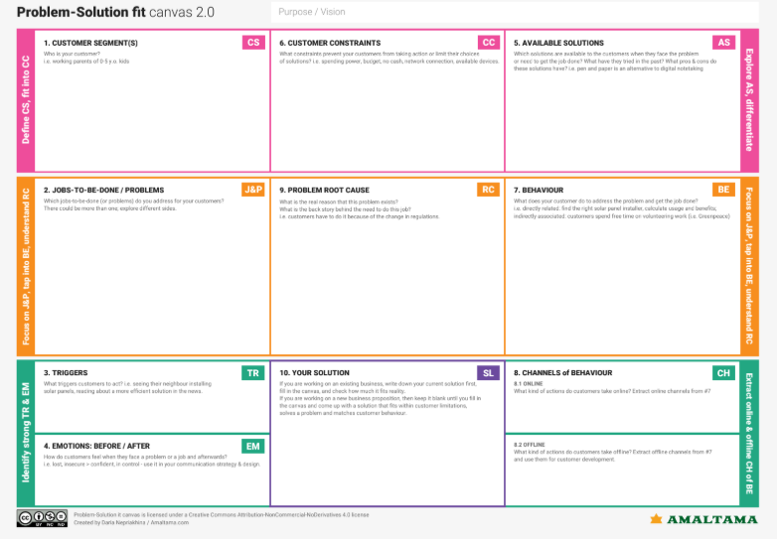

**Purpose:**

The main purpose of the Problem-Solution Fit Template is to validate that our project idea, **DocSpot**, directly addresses a genuine need in the healthcare space. By documenting the problem, target users, existing alternatives, and the proposed solution in one place, this template acts as a decision-making tool during development. It helps ensure that our focus remains on solving the right problems and building features that deliver real value to users.

**Problem-Solution Fit Template – DocSpot**

|  |  |
| --- | --- |
| **Section** | **Details** |
| **Problem Statement** | Patients face delays and difficulties in booking medical appointments due to lack of digital access, long queues, and unreliable communication. |
| **Target Users** | Patients, doctors, and clinic admins who want a seamless, trustworthy, and efficient healthcare appointment system. |
| **User Needs** | - Easy booking of doctor appointments - Verified doctors - Reliable communication - Appointment tracking - Secured login & data |
| **Existing Alternatives** | Manual booking, phone calls, hospital queues, or limited-feature third-party apps. |
| **Our Solution** | A full-stack web platform that allows users to register, apply as a doctor, get admin approvals, and book appointments with verified doctors. |
| **Key Features** | - User and Doctor dashboards - Admin panel - Real-time booking - Protected routes - Role-based access control |
| **Value Proposition** | Saves time, increases trust, centralizes medical appointments, and ensures convenience from any device. |